Non-funded Proposals

Policies
UM System Policy 23001- Records General Policy
UM System Policy 23002 – Storage and Disposal of University Records

Forms
None

Overview
Proposals for which support is denied by the sponsor or declined by the Principal Investigator is ultimately removed from the University’s list of pending projects. Maintaining accurate proposal status designation in the PeopleSoft Grants Module (PSGM) ensures useful submitted-to-funded ratio data. Non-funded proposal files are archived in accordance with sponsor requirements and otherwise held for reference for a reasonable and consistent amount of time.

Risk
Inconsistent proposal status portrays an inaccurate picture of both pending potential funding opportunities for the Principal Investigator and of submitted-to-funded ratio data for the University.

Procedure
Principal Investigator (PI)/Departmental Research Administrator (DRA) – The PI/DRA notifies the SPA Senior Grants and Contracts Administrator upon learning that a proposal will not receive funding support, providing any written communication from the sponsor as documentation. The PI also notifies the SGCA if he or she chooses not to accept funding for a pending or newly-awarded proposal.

SPA Senior Grants and Contracts Administrator (SGCA) – Upon receiving documentation from the PI/Department that a proposal was not funded or declined, the SPA SGCA updates the proposal status in the PSGM to “Not Funded”, saves the documentation to the electronic proposal file, and routes the file to the appropriate electronic storage unit for archiving for the appropriate record retention period.

In the event that the SGCA (instead of the PI or DRA) receives notification from the sponsor that the proposal was not funded, the SGCA forwards the notification to the PI/DRA via email and proceeds as indicated above.

Responsibilities
Below is an outline of responsibilities as they relate to this procedure.
PI/DRA:

- Notifies the SGCA upon learning that a proposal was not funded or is declined, providing documentation.

2

SPA:

- Notifies the PI/DRA when SPA receives a notice of non-funding, providing documentation.
- Updates the PSGM to reflect “Not Funded” status.
- Archives the SPA proposal file in accordance with sponsor requirements and University record retention policies.

Need Help?
If you have questions or comments related to this procedure, contact SPA at muresearchospa@missouri.edu or (573)-882-7560.

Creation Date
11/01/2013

Latest Revision Date
11/21/2019

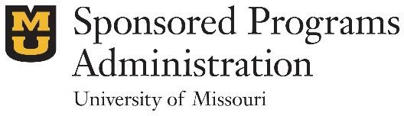
Sponsored Programs Administration
601 Turner Ave Garage | Columbia, MO 65211
573-882-7560 | grantsdc@missouri.edu

