Cost Transfers, Non-Payroll

Policies
Business Policy Manual: BPM-213, Correction of Income and Expense Items Business Policy and Procedure Manual: BPPM 2:190, Journal Entries

Forms
None

Overview
A cost transfer is a reallocation of costs after the initial transaction has occurred. Cost transfers occur in the regular course of business for two reasons: (1) to properly allocate multi-business unit expenses, and (2) to correct clerical or bookkeeping errors. Cost transfers are not appropriate for (1) spending out an unused award budget, (2) covering cost overruns, (3) avoiding restrictions imposed by law or other agreements, or (4) other reasons of convenience.

Any correction of income and/or expense items between Chartfields should be within two (2) accounting periods (months) after the end of the accounting period in which the original transaction was posted. Every effort should be made to record corrections in the fiscal year in which the original entry occurred.

Federal regulations stipulate that appropriate justification must be documented for all correcting entries (CE). Sufficient documentation includes the following: (1) justification as to why the transfer is necessary; (2) that the charge is allowable and allocable, directly benefits the award, and is within the period of availability; (3) that appropriate approvals are secured; and (4) in the case of error, how the error will be avoided in the future.

Risk
Inappropriate transfers could result in the disallowance of certain expenditures and/or possible reduction in funding from the sponsor agency. Inappropriate transfers could also jeopardize the reputation of the University and result in fines and sanctions.

Procedure
Principal Investigator (PI) – The PI has the overall responsibly to review award activity to ensure all CEs are allowable and allocable to the applicable projects. In order to have proper oversight, the PI should be aware of the applicable compliance requirements. The PI should request CEs in a timely manner when corrections are needed to non-payroll expenses.

Departmental Research Administrator (DRA) – The DRA assists the PI in ensuring that all transactions are properly recorded. The DRA processes expenditures and transactions, provides monthly budget variance reports for the PI to review, prepares cost transfers timely, and maintains documentation for all corrections.

SPA Post-award Team – The Post-award Team monitors award activity and determines with the Department when CEs are needed. Quarterly, the Post-award Team reviews the CE report (prepared by the SPA Compliance Team) for the following: (1) CEs that represent 10% of the

2

total award amount, (2) entries 30 days prior to the award end date, and (3) entries made after the award period. The Post-award Team works with the Department and adds approver comments as needed.

SPA Compliance Team – The Compliance Team generates a CE report quarterly and distributes to the Post-award Pods. The Compliance Team reviews all CEs prepared internally ensuring proper segregation of duties.

Responsibilities
Below is an outline of responsibilities as they relate to this process.
Principal Investigator:
- Maintains knowledge of compliance requirements.
- Ensures all cost transfers are allowable, properly documented, and made in a timely manner.

Departmental Research Administrator:
- Maintains knowledge of compliance requirements.
- Ensures transactions are properly recorded and supported.
- Prepares CEs timely.
- Retains supporting documentation according to the record retention requirements outlined in the terms and conditions of the applicable award or according to University record retention policies, whichever is more conservative.
- Provides supporting documentation to SPA.

Office of Sponsored Programs Administration:
- Reviews CEs and monitors quarterly.

Need Help?
If you have questions or comments about this procedure or the required form, contact SPA at muresearchospa@missouri.edu or (573)-882-7560.

Related Topics
Record Retention (in development)

Creation Date
05/29/2013

Latest Revision Date
05/29/2013

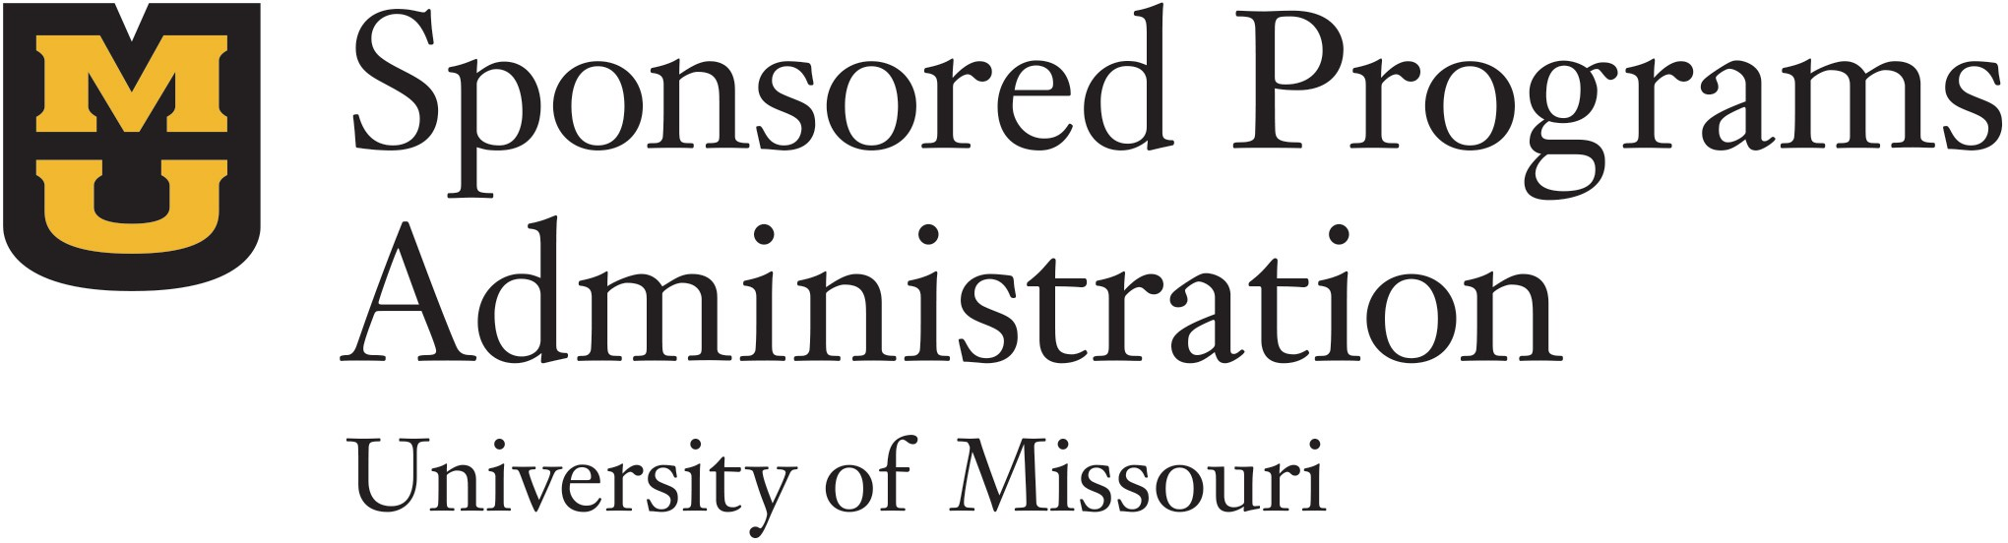
Sponsored Programs Administration
601 Turner Ave Garage – Room 201
Columbia, MO 65211-0001
573-882-7560 | grantsdc@missouri.edu

