Clinical Trials: Indirect Cost Recovery

Policies
Policy 27025 – Facilities and Administrative Costs NIH Office of Science Policy: Clinical Trial Definition

Forms
Grant Fact Sheet

Overview
As an exception the University of Missouri’s federally-negotiated indirect cost rate applicable to research, a “clinical trial,” as defined below, is subject to a rate of 26 percent. This reduced rate is consistent with clinical trial indirect cost rates employed by other research universities. The rate applies to total direct cost (TDC); no budgeted item is excluded from the base to which the indirect rate is applied.

When a commercial or industry firm requires rights in data to the exclusion of the University and/or claims ownership rights to intellectual property developed by the University under a clinical trial project, indirect costs must be charged at a rate not less than the clinical trials rate plus five (5) percent.

MU’s definition of a clinical trial for the purpose of application of 26% (or 31%) indirect rate: The controlled, clinical testing in human or vertebrate animal subjects of investigational new drugs, devices, treatments, or diagnostics, or comparisons of approved drugs, devices, treatments, or diagnostics, to assess their safety, efficacy, benefits, costs, adverse reactions, and/or outcomes. Such studies may be conducted under an industry-developed protocol or an investigator- developed protocol.

These studies are most often conducted in conjunction with obtaining new drug or device approval from the U.S. Food and Drug Administration, under Phase I, II, III, or IV, although they can be designed with the sole purpose of collecting and analyzing data about approved drugs or devices or behavioral interventions in order to contribute to medical knowledge about the prevention or treatment of a disease or medical condition.

Financial support for a clinical trial must be provided by a private entity, including but not limited to pharmaceutical companies, interest groups, charities, or foundations. The University’s federally-negotiated rates apply to all federally-funded clinical trials, whether the funds are awarded directly from the sponsor or flow through an intermediary sponsor. The University will not relinquish ownership rights to intellectual property developed under federally funded clinical trials, whether the funding is awarded directly or flows through a private entity intermediary sponsor because such federally funded research is governed by the Bayh-Dole Act.

In all cases, the study must include the prospective enrollment of human or vertebrate animal subjects and the controlled testing of a drug, device, treatment, or diagnostic under an approved protocol. Retrospective chart reviews, analysis of existing medical data and records, laboratory research, and federally funded projects are not categorized as clinical trials for purposes of applying the approved clinical trial indirect rate.

Any deviation from this definition in determining the applicable rate must be approved by the Vice Chancellor for Research, Innovation & Impact.

Need Help?
Contact OSPA at muresearchospact@missouri.edu or 882-7560.
Related Topics Indirect Cost Recovery
Intellectual Property

Effective Date
04/13/2016

Last Revision Date
11/05/2024

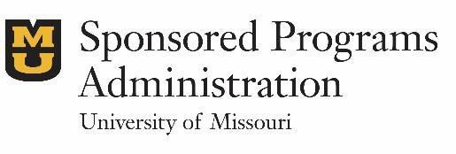
Sponsored Programs Administration 601 Turner Ave | Columbia, MO 65211 573-882-7560 | grantsdc@missouri.edu

