Financial Conflict of Interest under the 2011 Revised PHS Regulation

Policies
University of Missouri Collected Rules and Regulations sections 330.015, Policy on Conflict of Interest, and 420.030, Conflict with the Interests of Federal Grant Agencies
University of Missouri-Columbia corresponding Procedures on Conflict-of-Interest Management

Forms
Investigator Form
Conflict of Interest Disclosure Form (eCompliance)
Subrecipient Commitment Form
Subrecipient Letter of Intent (for use with FDP Member Institutions)

Overview
On August 25, 2011, the Department of Health and Human Services issued a final rule (76 FR 53293) entitled “Responsibility of Applicants for Promoting Objectivity in Research for which Public Health Service Funding is Sought” (42 CFR Part 50, Subpart F) and “Responsible Prospective Contractors” (45 CFR Part 94). An Institution applying for or receiving PHS funding (including but not limited to NIH) must be in full compliance with all regulatory requirements of the new rule as of August 24, 2012.

The financial conflict of interest (FCOI) policy applies to proposals for and awards of PHS funding and funding from any other sponsors having adopted the 2011 PHS FCOI regulation requirements.

The Public Health Service (PHS) includes the following offices and operating divisions:
- Administration for Children and Families (ACF)
- Administration on Aging (AoA)
- Agency for Healthcare Research and Quality (AHRQ)
- Agency for Toxic Substances and Disease Registry (ATSDR)
- Centers for Disease Control and Prevention (CDC)
- Centers for Medicare & Medicaid Services (CMS)
- Federal Occupational Health (FOH)
- Food and Drug Administration (FDA)
- Health Resources and Services Administration (HRSA)
- Indian Health Service (IHS)
- National Institutes of Health (NIH)
- Office of the Assistant Secretary for Health (OASH)
- Administration for Strategic Preparedness and Response (ASPR)
- Office of Global Affairs (OGA)
- Substance Abuse and Mental Health Services Administration (SAMHSA)
- Public Health Service Commissioned Corps.

A partial list of agencies and organizations which have adopted the 2011 PHS FCOI regulation requirements is provided below:
- Alliance for Lupus Research (ALR)
- Alpha-1 Foundation
- American Asthma Foundation (AAF)
- American Cancer Society (ACS)
- American Heart Association (AHA)
- American Lung Association (ALA)
- Arthritis Foundation (AF)
- CurePSP
- Department of Energy (DOE)
- Department of Interior (DOI)
- Juvenile Diabetes Research Foundation (JDRF)
- Lupus Foundation of America (LFA)
- National Science Foundation (NSF)
- National Aeronautics and Space Administration (NASA)
- Patient-Centered Outcomes Research Institute (PCORI)
- Susan G. Komen for the Cure (Komen)
- United States Department of Agriculture (USDA)

Note:. Regardless of the funding agency (e.g., Department of Defense, Department of Energy, National Science Foundation etc.), for purpose of complying with university conflict of interest policy, all SBIR/STTR proposals and awards will be entered into eCompliance for oversight by the COI Office.

Impact Summary
For each proposal funded by any PHS agency or sponsor who has adopted the regulation (including those for which MU is the subrecipient):

At Proposal:

- All MU Investigators must have submitted a Conflict of Interest (COI) Disclosure Form to the COI Office via eCompliance within the previous 12 months.
- All external (non-MU) Investigators must provide certifications or disclosures appropriate to their role on the project and professional affiliation(s).
- The Principal Investigator (PI)/Department must submit an Investigator Form (IF) and the required documentation of submitted COI Disclosures/certifications to SPA with the grant application and Electronic Proposal Signature Routing Sheet (ePSRS).

Note: Proposals impacted by the regulation will not be submitted until all requirements are met, regardless of the sponsor’s submission deadline.

At Award:

- All MU Investigators must complete Conflict of Interest Training through eCompliance.
- All MU Investigators must have a current COI Disclosure Form on file in eCompliance.
- The MU Conflict of Interest Committee (COIC) will determine if there is a financial conflict of interest (FCOI) that could impact the project. If so, the COI Office will work with the Investigator to create a management plan. Upon final approval of the management plan, the COI Office will report the FCOI and the management plan to the sponsor.

Note: Projects will not be awarded until all requirements are met, regardless of the sponsor’s awarded start date.

During the Project:

- No new Investigators may be added to a project until they have completed all of the above requirements. The PI/Department must notify the COI Office before adding personnel and must provide an updated Investigator Form (IF). To alert the COI Office, SPA must enter a PI/personnel change amendment notification in eCompliance, and upload the new IF,
- Investigators must report all sponsored travel, as defined by the regulation, no later than 30 days after the travel occurred.
- Prior to acquiring any new outside interests or making any changes to existing interests, Investigators must update their COI Disclosure in eCompliance.

Risk
An organization’s failure to comply with the PHS regulation may result in a variety of actions at the discretion of the sponsor, including but not limited to imposing special conditions on a grant, terminating an award, and refusing future funding. At the University level, the COIC has the authority to recommend sanctions of an employee for failure to cooperate with or violation of COI policy (CRR 330.015.A.2; CRR 420.030 F).

Quick Links

Sections
- At Proposal
- At Award
- During the Project

Appendices
- External Investigators
- FCOI Quick Reference Guide for DRAs

SECTION I. AT PROPOSAL
Procedure
Principal Investigator (PI) – The PI completes the Investigator Form (IF) for the proposal, with the assistance of the COI Office as needed.

Note: All Senior/Key Personnel (including the PI) and Other Significant Contributors (OSC) as designated on the Research & Related (R&R) Senior/Key Person Profile form or other sponsor profile form must be listed on the IF.

Note: The PI’s physical signature stated approval by email, or electronic signature (by way of direct submission to SPA) are acceptable approvals of the IF.

Departmental Research Administrator (DRA) – The DRA works with the PI to complete the IF and accesses the eCompliance database (Documents tab) to verify that all MU Investigators listed on the IF have filed a COI Disclosure Form within the previous 12 months. (Note that the DRA’s eCompliance access is limited such that the content of the MU Investigators’ disclosure cannot be viewed.) The DRA saves screenshots or prints screens as documentation of current disclosures for all MU Investigators.

Note: The following statuses indicate that a COI Disclosure Form has been submitted to the COI Office: Submitted, Returned, Under Review, Complete. The only status that does not meet the requirement for proposal submission is New. “New” indicates that an individual has started completing the disclosure but has not finished and submitted it to the COI Office.

If an MU Investigator has not submitted a COI Disclosure Form, the DRA should provide guidance to the MU Investigator to access eCompliance or alert the COI Office and SGCA. As the submission deadline approaches, the COI Office will work with the MU Investigator to submit the disclosure and keep the DRA and SGCA informed of progress or potential delays.

For any external subrecipient (non-MU) Investigator included in the proposal, the DRA will send the Subrecipient Commitment Form (SCF) (or the Subrecipient Letter of Intent (LOI) for those subrecipient institutions who participate in the FDP Expanded Clearinghouse), to be completed by the subrecipient and signed by the Subrecipient Authorized Official (see Appendix 1).

Note: In most circumstances, a subrecipient may not rely on the MU FCOI policy. If a subrecipient does not have an active and enforced COI policy, the DRA should contact the SGCA and the COI Office. The COI Office will take the lead in offering the subcontractor the FDP Model Financial Conflict of Interest Policy and Model Disclosure Form for adoption. If the COI Office agrees to subsume the subrecipient investigator(s), they must complete and submit the external investigator disclosure form in eCompliance prior to submission.
Note: In the event certification or an external disclosure cannot be obtained, the subrecipient investigator must be removed from the proposal prior to submission.

For any external non-subrecipient (non-MU) Investigator(s) included in the proposal, the DRA should work with the SGCA to contact the COI Office to determine and secure the required disclosure or certification appropriate to the Investigator’s role on the project and professional affiliation(s).

Note: In the event certification or an external disclosure cannot be obtained, the external investigator must be removed from the proposal prior to submission.
(see Appendix 1).

Note: PHS proposals will not be submitted until all requirements are met, regardless of the sponsor’s submission deadline.

The DRA submits as part of the proposal package the following: (1) a completed IF signed by the PI, (2) screenshots or printed and scanned pages from eCompliance confirming that each MU Investigator has a current COI Disclosure on file, and (3) if applicable, a completed SCF or Letter of Intent (LOI) signed by the Subrecipient Authorized Official.

SPA – At proposal, the SGCA will:
  - Verify that the PI has completed, signed, and submitted an Investigator Form for the project.
  - Compare the IF to the Research & Related (R&R) Senior/Key Person Profile form or other sponsor designated personnel form and contact the Department/Division to resolve any inconsistencies, involving the COI Office when necessary.
Note: All Senior/Key Personnel (including the PI) and Other Significant Contributors (OSC) as designated on the R&R Senior/Key Person Profile form must be listed on the IF.

  - Review the documentation submitted by the DRA and/or verify via the eCompliance database (Document tab) to verify that all MU Investigators on the IF have filed a COI Disclosure Form within the previous 12 months. Retain documentation for the SPA proposal file. (Note that the SGCA’s eCompliance access is limited such that the content of COI Disclosures cannot be viewed.) If an MU Investigator has not submitted a disclosure, the SGCA should alert the COI Office who will work with the MU Investigator to submit a COI Disclosure Form, keeping the SGCA informed of the status of the request.

  - For proposed subrecipient(s), review the SCF(s) or LOI(s) to verify that the subrecipient institution(s) has certified it has a publicly accessible FCOI policy compliant with sponsor regulations.
Note: In most circumstances, a subrecipient may not rely on the MU FCOI policy. If a subrecipient does not have an active and enforced FCOI policy, the SGCA will contact the COI Office who will offer the subrecipient the FDP Model Financial Conflict of Interest Policy and Model Disclosure Form for adoption. The policy is here. If the COI Office agrees to subsume the subrecipient investigator(s), they must complete and submit the external investigator disclosure form in eCompliance prior to submission.

IMPORTANT: In the event certification or an external disclosure cannot be obtained, the subrecipient Investigator must be removed from the proposal prior to submission.

  - For external non-subrecipient (non-MU) Investigators, work with the COI Office to determine and secure the required disclosure or certification appropriate to the Investigator’s role on the project and professional affiliation(s).

IMPORTANT: In the event certification or an external disclosure cannot be obtained, the external Investigator must be removed from the proposal prior to submission.

COI Office – Prior to proposal submission, the COI Office will, at the request of the SGCA or Department/Division, work with an MU Investigator to complete a COI Disclosure Form and will keep SPA informed of its status.

The COI Office fields questions from the PI and Department/Division relating to the COI policies, including questions regarding how to identify an “Investigator.”

Responsibilities:
Below is an outline of responsibilities as they relate to this process at proposal.

Principal Investigator:
  - Identify all Investigators named in the proposal by completing the Investigator Form (IF).

Departmental Research Administrator (DRA):
  - Work with the PI to complete the IF.
  - Verify that all MU Investigators listed on the IF have filed a COI Disclosure Form within the previous 12 months. If an MU Investigator does not have a current disclosure on file, the DRA should immediately alert the COI Office and the SGCA.
  - If applicable, send the Subrecipient Commitment Form (SCF) or Subrecipient Letter of Intent (LOI) to be completed by each subrecipient and signed by an Authorized Official. If the subrecipient indicates that it does not have a compliant FCOI policy, work with the SGCA who will contact the COI Office (see Appendix 1).
  - Work with the SGCA to contact the COI Office regarding any external non-subrecipient (non-MU) Investigators on the project in order to determine the appropriate required disclosures or certifications (see Appendix 1).
  - Submit to SPA the IF, eCompliance COI Disclosure documentation, and SCF(s)or LOI(s) (if applicable) with the grant application and ePSRS.

Office of Sponsored Programs Administration:
  - Review the IF for completeness and accuracy compared to the PHS application forms.
  - Review the documentation submitted by the DRA verifying that all MU Investigators listed on the IF have filed a current COI Disclosure. If an MU Investigator has not submitted a disclosure, the SGCA should immediately alert COI Office staff.
  - For any external subrecipient (non-MU) Investigators, ensure that the subrecipient
institution has certified it has a publicly accessible FCOI policy compliant with sponsor regulations.
  - For any external non-subrecipient (non-MU) Investigators, work with the COI Office to determine and secure the required disclosure or certification appropriate to the Investigator’s role on the project and professional affiliation(s).
  - Following proposal submission, maintain documentation of the certification forms
for the SPA proposal file.

COI Office:
  - Field questions from the PI and Department/Division relating to the COI policies.
  - When necessary, work with MU Investigators to complete a COI Disclosure prior to proposal submission and keep Department/Division staff and/or SPA informed of its status.
  - Work with SPA to determine and secure the required disclosures or certifications for
external non-subrecipient (non-MU) Investigators.

SECTION II. AT AWARD
Procedure
PI – The PI collaborates with the COI Office and the Conflict of Interest Committee (COIC) as needed during the COI review process and ensures that all MU Investigators complete the Conflict of Interest Training in eCompliance.

SPA – The SGCA notifies the COI Office via eCompliance (Projects tab) upon receiving a request for an Advance/Pre-Award Account from the PI and Department/Division or a Notice of Award from the sponsor. The SGCA creates a New Project Notification and Award Notification entry in eCompliance and will upload the project Investigator Form and Scope of Work from the original Proposal file to facilitate the COI review.
Note: COI review and approval are not required prior to submission of Just in Time (JIT) information. NIH’s request for JIT information provides early notice of possible intent to fund, however, a request for JIT information is not an award notification and does not provide certainty that a proposal will ultimately receive funding; therefore, COI review and approval will occur when the Notice of Award is received from the sponsor.

Upon award, the SGCA will review the agreement and collect applicable approvals (e.g., PI, legal, IRB/ACUC) while the COI Office completes the COI review. Agreements requiring University signature can be executed during the COI review process; however, the award cannot be set up until the COI review is complete and the COI Office issues an Expend Funds letter to SPA.
Note: In the event that MU is a subrecipient on an award subject to this requirement (i.e., MU’s sponsor is another institution issuing a subaward agreement with flow-through dollars), the SGCA will obtain a copy of the prime agreement for the SPA file.

COI Office – The COI Office initiates the COI review upon receiving the Award Notification in eCompliance, working to ensure the review is completed in a timely manner based on the project start date identified by SPA in the eCompliance notification. The COI Office 1) Works with the PI to verify the Investigator Form is accurate and current (within the last 30 days from the date of its approval), 2) Verifies all Investigators have submitted a COI Disclosure Form (within the last 12 months), 3) Verifies all Investigators have completed COI Training (within the last 4 years), and 4) Reviews all outside entities disclosed by all Investigators to determine if there is a financial conflict of interest (FCOI) associated with the project.

For any identified FCOI, the COI Office will work with the Investigator and Chair/Dean to create a project management plan. Upon final approval of the management plan, the COI Office will report the FCOI and management plan to the sponsor. In order to ensure proper award management, the COI Office will inform SPA of any potential impact on the project.

The COI Office will notify the SGCA, Post-award Team, and DRA by email that all PHS requirements have been met for the awarded project, indicating that all MU Investigators have a current COI Disclosure form on file, have completed Conflict of Interest Training, and either (1) there is no FCOI related to the project or (2) an FCOI management plan has been developed and reported to the sponsor.

The COI Office will review FCOIs submitted to MU by any subrecipient on a project and will submit their reports to the sponsor at award and annually, as specified in the regulation.
Note: SPA will utilize the FDP Subaward Agreement Forms, which include language
relevant to the FCOI regulation. Additional language will be added as needed on a case-by-case basis.

The COI Office will submit all required FCOI reports to the sponsor, including annual updates required for previously reported FCOIs.

SPA - The SGCA maintains documentation of the COI Office/COIC approval in the SPA file. The award can be set up upon receipt of the above approval notification.

Responsibilities
Below is an outline of responsibilities as they relate to this process at award.

Principal Investigator:
  - Collaborate with the COI Office and COIC to expedite approval.
  - Work with MU Investigators to ensure all complete Conflict of Interest Training.

Sponsored Programs Administration:
  - Notify COI Office via eCompliance upon notice of new or additional funding, attaching the project’s Investigator Form and Scope of Work and, if applicable, including subrecipient information.
  - Maintain COI Office/COIC approval documentation in the SPA file.
  - Hold award setup until notification of COI Office/COIC approval (Expend Funds Letter).

COI Office:
  - Initiate COI review process upon notification of impending award.
  - Facilitate management plan development when necessary.
  - Ensure all MU Investigators have a current COI disclosure and complete COI training.
  - Notify SPA of COI Office/COIC approval (Expend Funds Letter).
  - Submit all required FCOI reports (including those of subrecipients) to the sponsor.

SECTION III. DURING THE PROJECT
Procedure
Investigators – MU Investigators must report any sponsored travel2 to the COI Office via eCompliance within 30 days of the trip and must report any new or changed outside interests by submitting an updated COI Disclosure Form via eCompliance as new interests arise. Subrecipient external (non-MU) Investigators must meet the same requirements by reporting to the MU COI Office as directed by the subaward agreement.

DRA/SPA – The DRA and SPA work closely together for compliant and consistent post-award administration.

COI Office-The COI Office monitors the award for COI compliance and works with investigators to ensure they maintain current COI disclosures in eCompliance and complete COI training every 4 years. The COI Office will contact the SPA Post-Award Team, as needed, to determine project status as it relates to ensuring COI compliance is maintained throughout the completion and closeout of the project.

Change in Investigators
Note: Before the PI adds a new MU Investigator to an ongoing project, the new MU Investigator must submit a COI Disclosure Form in eCompliance and complete Conflict of Interest Training. The SGCA must alert the COI office who will complete a COI review.

PI – The PI completes a revised Investigator Form (IF).

DRA – The DRA works with the PI to complete the revised IF. The DRA ensures that all MU Investigators, as defined by the regulation, have submitted a COI Disclosure Form via eCompliance in the previous 12 months and that external (non-MU) Investigators have provided the appropriate disclosures or certifications (see Section I above and Appendix 1).The DRA submits the revised IF to SPA.

SPA – The SGCA or Post-Award Team will alert the COI Office by submitting an amendment notification to the award entry in Compliance, adding a comment to the notes section describing the PI/personnel changes, and uploading the new IF. If there are subrecipients on the award, the SGCA or Post-Award Team will enter the subcontractor information.

COI Office – Upon receipt of the amendment notification and new IF, the COI Office will complete a COI review. If relevant, the COI Office facilitates development of a management plan for any identified FCOIs and submits to the sponsor an FCOI report within 60 days of determining that a new or newly discovered FCOI exists. Once all COI requirements have been met, the COI Office will send the approval notification (Expend Funds Letter) to the PI, DRA, SGCA, and Post- award Team.

2Sponsored travel includes all travel sponsored or reimbursed by any entity other than MU, with the following exceptions for which reporting is not required: a federal, state, or local government agency; an institution of higher education; an academic teaching hospital; a medical center; or a research institute that is affiliated with an institution of higher education.

Continuation Funding Notices (Including No Cost Time Extensions)

SPA – The SGCA enters an Award Notification via eCompliance (Projects tab) upon receipt of the Notice of Award for the continuation funding.
Note: COI review and subsequent COI Office approval are not required prior to
submission of annual progress reports. Note that regardless of proactive internal processes, progress report submission does not provide certainty that a project will receive additional funding.

COI Office – Upon receipt of a Notice of Award for continuation funding in eCompliance, the COI Office works with the PI/DRA to confirm that the Investigator Form (IF) and Scope of Work (SOW) on file are complete and accurate for the anticipated continuation period. The COI Office sends an “Award Review/Update IF Notification” by email and works with the PI/DRA as needed to complete the process. The COI Office notifies SPA of any updates submitted.

For any previously reported FCOI, the COI Office submits an annual FCOI report at the time of continuation application submission.
In anticipation of next year’s funding, the COI Office and SPA follow procedures as outlined in Section II above.

Responsibilities
Below is an outline of responsibilities as they relate to this process during the project.

Principal Investigator:
  - Work with the DRA to report any change in Investigators by way of a revised IF.
  - Report all sponsored travel within 30 days of the trip; ensure all Investigators report sponsored travel.
  - Prior to engaging in, or acquiring any new or changed outside interests, update the COI Disclosure Form in eCompliance; and ensure all Investigators do the same.

Departmental Research Administrator:
  - Work closely with the SPA Post-award Team for compliant and consistent post-award administration.
  - Work with the PI to complete and submit a revised IF upon any notice of a change in Investigators on a project and await COI Office approval before processing appropriate payroll changes to the project.
  - Work with SPA to notify the COI Office upon learning of a change in Investigators or an investigator’s outside interests or an instance of sponsored travel.

Office of Sponsored Programs Administration:
  - Submit revised IFs to the COI Office upon receipt from the PI and/or Department/Division by submitting an amendment notification to the award entry in eCompliance, and uploading the new IF
  - Notify the COI Office when submitting to the sponsor an Investigator Change Request.
  - Notify the COI Office when continuation notice of award is received by submitting the award notification in eCompliance.
  - Notify the COI Office upon learning of a change in Investigators or outside interests or an
instance of sponsored travel.

COI Office:
  - Upon receipt of the award notification in eCompliance, confirm that the IF and SOW on file are complete and accurate for the anticipated continuation period.
  - Ensure that all new Investigators on a project submit a COI Disclosure and complete the Conflict of
  - Interest Training.
  - Conduct a COI review of any outside activities disclosed by the Investigators to determine if there is a FCOI.
  - Facilitate development of a project management plan for any identified FCOIs.
  - Submit to sponsor an FCOI report within 60 days of determining a new or newly discovered FCOI exists.
  - For any previously reported FCOI, submit an annual FCOI report at the time of renewal
application.
  - Upon notification of continuation application, submit necessary FCOI reports concurrently.
  - Once all COI requirements have been met, notify SPA of COI Office approval (Expend Funds Letter).

Need Help?
Contact SPA at muresearchospa@missouri.edu or (573)-882-7560.

Related Topics
Advance and Pre‐ award Accounts

Creation Date

08/23/2012

Latest Revision Date
04/03/2026

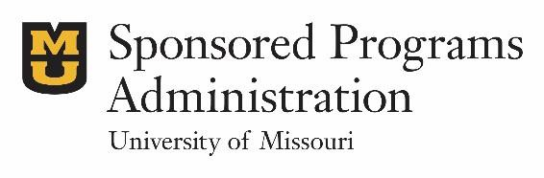
Sponsored Programs Administration
601 Turner Ave | Columbia, MO 65211
573-882-7560 | grantsdc@missouri.edu

APPENDIX 1. EXTERNAL INVESTIGATORS
When a PI has identified an external (non-MU) Investigator, MU must arrange for the management of the Investigator’s conflicts in one of two ways, described below. If neither option is viable, the external Investigator must be removed from the project.

Note: Not all collaborators and consultants meet the definition of Investigator. If the PI determines that the individual’s role on the project does not rise to the level of Investigator, the individual should be listed as an Other Significant Contributor (OSC) on the Research & Related (R&R) Senior/Key Person Profile form or other sponsor designated personnel form and the requirements under the PHS COI Rule do not apply .

MU SUBRECIPIENT: Include in the proposal a subcontract with the Investigator’s employer and obtain certification of the employer’s COI policy (preferred method).
  - Generally (but not absolutely), the external Investigator’s role will be co-Investigator (co-
I) or co-Principal Investigator (co-PI).
  - Prior to proposal submission, subrecipients on all proposals subject to the revised PHS FCOI regulation must certify as to the institution/organization’s Conflict of Interest policy.

Subrecipient Commitment Form: COI Assurance
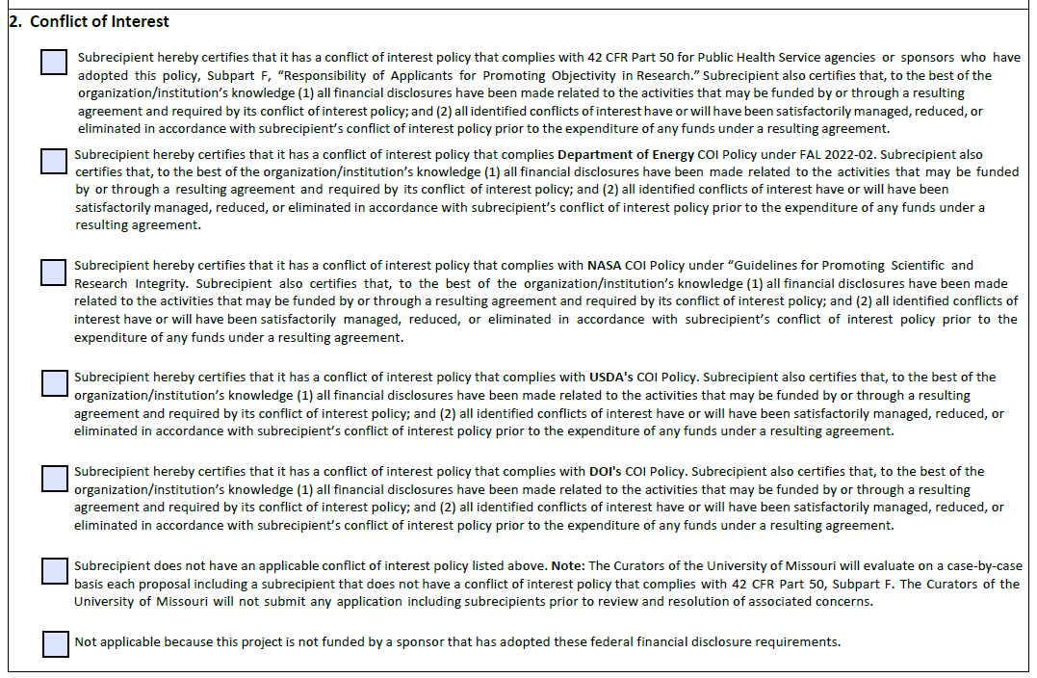

The Departmental Research Administrator (DRA) sends the Subrecipient Commitment Form (SCF) to be completed by the subrecipient and signed by the Subrecipient Authorized Official. For projects subject to FCOI regulations, a completed SCF indicates to MU that (1) the subrecipient institution/organization has a publicly accessible FCOI policy that complies with the sponsor regulations and will timely submit required reports to MU, or (2) the subrecipient institution/organization does not have a compliant FCOI policy and therefore must adopt one, rely on MU’s policy, or be removed as an Investigator on the project.

If a subrecipient does not have an active and enforced FCOI policy, the DRA should work with the SGCA to notify the COI Office immediately. In most circumstances, a subrecipient may not rely on the MU COI policy. The COI Office will take the lead in offering the subcontractor the FDP Model Financial Conflict of Interest Policy and Model Disclosure Form for adoption. If the COI Office agrees to subsume the subrecipient investigator(s), they must complete and submit the external investigator disclosure form in eCompliance prior to submission.
Note: In the event certification or an external disclosure cannot be obtained, the subrecipient investigator must be removed from the proposal prior to submission.

The DRA submits the completed and signed SCF(s) to SPA as part of the proposal package. SPA reviews the SCF(s) to verify that the proposed subrecipient institution(s) has certified that it has a publicly accessible FCOI policy compliant with sponsor regulations.

At award, SPA will utilize the FDP Subaward Agreement Forms, which include language relevant to the FCOI regulation. Additional language will be added as needed on a case-by- case basis.

The COI Office will review FCOIs submitted to MU by any subrecipient on a project and will submit their reports to the sponsor at award and annually, as specified in the regulation.

Federal Demonstration Partnership (FDP) Institutional Clearinghouse for Certification of Institutional Compliance with PHS FCOI Requirements

The FDP hosts a Clearinghouse of institutions and other entities that have attested as to their compliance with the revised PHS FCOI regulation. The FDP Clearinghouse is intended for use by recipients of PHS funding to verify the compliance of their potential subrecipients with these regulations. MU is enrolled in the FDP FCOI Clearinghouse. If a subrecipient has not confirmed if they have a compliant policy, SPA can check the FDP Clearinghouse to see if they have attested compliance with the PHS FCOI regulation.

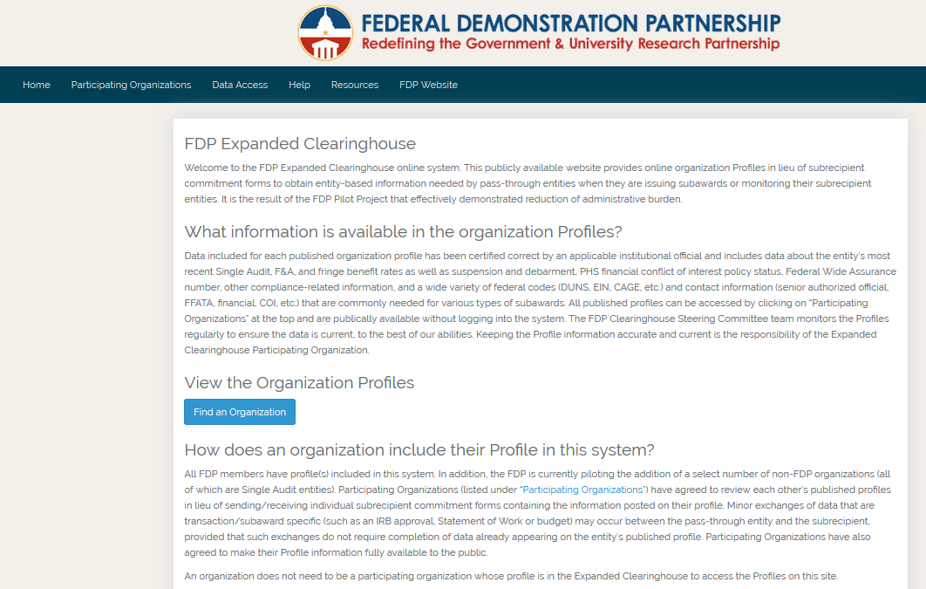

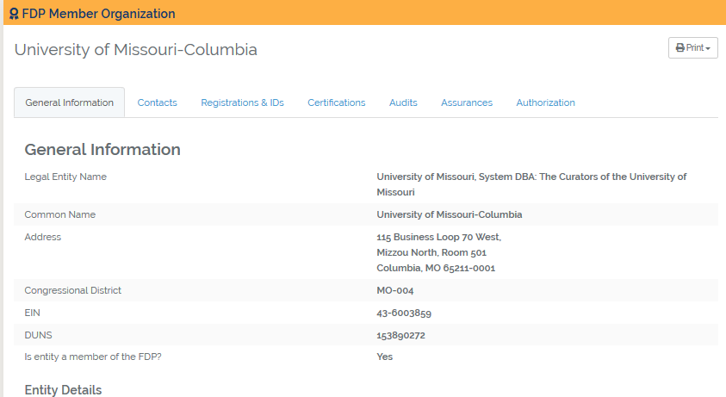

SUBSUMED INVESTIGATOR: Bring the individual under MU’s COI Policy (acceptable method only if subcontracting to the individual’s employer is not an option).
Note: Including in the proposal a subcontract with the Investigator’s employer and
obtaining certification of the employer’s FCOI policy (option 1, above) is preferred; a contractual relationship between entities provides sufficient evidence to MU that the employer has assumed legal liability for the external actions of its employee(s). Where no contractual relationship exists, an employer’s FDP Clearinghouse certification or Letter of Commitment (including Authorized Organizational Representative signature) does not provide sufficient evidence of institutional responsibility, and the individual must either be subsumed under MU’s COI Policy, or removed from the proposal prior to submission (if certification or an external disclosure cannot be obtained).
  - The PI/DRA should work with the SGCA, who will contact the COI Office, to determine
required disclosure/certification. If the COI Office agrees to subsume the subrecipient investigator(s), they must complete and submit the external investigator disclosure form in eCompliance prior to submission. In the event certification or an external disclosure cannot be obtained, the subrecipient investigator must be removed from the proposal prior to submission.
Generally, the external Investigator’s role will be collaborator or consultant.

APPENDIX 2. FCOI QUICK REFERENCE GUIDE FOR DRAS

(next page)

FCOI Quick Reference Guide for DRAs
For full procedures, refer to “COI Review Reference Guide” in the SPA Sponsored Programs Procedure Guide.

For each PHS* proposal (including those for which MU is the subrecipient):
*Includes all sponsors having adopted the PHS FCOI Rule. Refer to the Investigator Form for more information.

At Proposal, the DRA should:
- Work with the PI to complete the Investigator Form (IF), listing all Investigators (MU and non-MU).
Note: All Senior/Key Personnel and OSCs on the R&R Senior/Key Person Profile form must be listed on the IF.
- Verify that all MU Investigators listed on the IF have filed a COI Disclosure within the previous 12 months. If an MU Investigator does not have a current disclosure on file, provide guidance to the MU Investigator to access eCompliance or alert the SGCA.
- For any external subrecipient (non-MU) Investigator, obtain a Subrecipient Commitment Form (SCF) or Letter of Intent (LOI) and confirm COI policy certification. If the subrecipient indicates that it does not have a compliant policy, work with your SGCA to contact the COI Office.
- For any external non-subrecipient Investigator, work with your SGCA to contact the COI Office.
- Submit the following to SPA: (1) IF, (2) eCompliance COI Disclosure status screenshots, (3) SCF or LOI, if applicable.
Note: Proposals will not be submitted until it is confirmed that all MU Investigators have a current COI Disclosure on file and all non-MU Investigators have made appropriate disclosures/certifications.

At Award:
- The SGCA will notify the COI Office upon receiving a Pre-Award Account request, Notice of Award, or any other indication of funding.
- All MU Investigators must have an updated COI Disclosure in eCompliance complete COI Training.
- Agreements requiring University signature can be executed during the COI review process; however, the award cannot be set up until the COI review is complete and SPA receives COI Office approval (Expend Funds Letter).
Note: The COI Office will ensure all requirements are met and then notify SPA. Projects will not be awarded prior to COI Office approval, regardless of the sponsor’s awarded start date.

During the Project:
- All Investigators must (1) prior to acquiring new outside interests or making changes to existing interests, submit an updated COI Disclosure in eCompliance, (2) report sponsored travel within 30 days, (3) update their COI Disclosure annually, and (4) complete COI Training at least every four years.

Change in Investigators:
- Before the PI adds a new Investigator to an ongoing project, the COI Office must be alerted of the PI/personnel change, must receive a new IF, and must complete a COI review to ensure compliance with all requirements.
The DRA should:
- Work with the PI to complete and submit a revised IF upon any notice of a change in Investigators on a project.
- Await COI Office approval before processing appropriate payroll changes to the project.

Need Help? Contact grantsdc@missouri.edu, or the COI Office.

A financial conflict of interest (FCOI) is a significant financial interest that could directly and significantly affect the design, conduct, or reporting of research.
A complete listing of agencies who have adopted the PHS FCOI regulation is not available, please consult with the private agency directly for accuracy.

