PSRS Questionnaire | GENERAL

Submission Deadline: Click or tap here to enter text.
Proposal Title: Click or tap here to enter text.
(Is this tentative or final?): Click or tap here to enter text.
Start/End Dates: Click or tap here to enter text.
Purpose (choose ONLY 1): Research: ☐ Basic ☐ Applied ☐ Development
☐ Other Sponsored Activity ☐ Instruction
Award Purpose Determination Guide (Click Here)

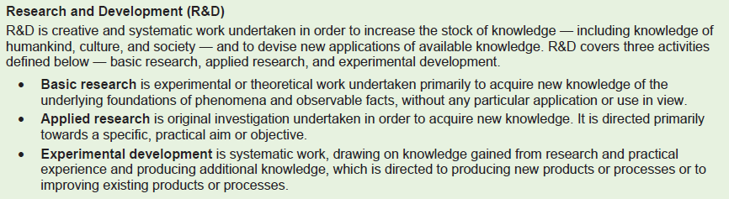

Keywords (up to 5): Click or tap here to enter text.

Funding Agency/Primary Sponsor: Click or tap here to enter text.

Solicitation Link: Click or tap here to enter text.

MU’s Direct Sponsor (If MU is a subrecipient): Click or tap here to enter text.

Sponsor Contact Name: Click or tap here to enter text.
Sponsor Contact Phone Number: Click or tap here to enter text.
Sponsor Contact Email: Click or tap here to enter text.

Will we have any subrecipients? ☐ Yes ☐ No If yes, list institutions and contact information: Click or tap here to enter text.

ACUC (animals) or IRB (human subjects) involved? ☐ Yes ☐ No If yes, provide details: (approval number/date, exemption number, pending status, etc): Click or tap here to enter text.

If an NIH proposal: Does the proposed research involve human specimens and/or data? ☐ Yes ☐ No

Is this proposal being submitted to any other sponsors? If so, to whom? Click or tap here to enter text.
Abstract (This will be included on the ePSRS and may be used by RII):
Click or tap here to enter text.

Check all that apply: (checked = YES)
☐ | Is this a Multi-UM Campus project (Rolla, UMKC, UMSL, System, Extension)?
☐ | Is this project related to a University License or assigned patent?
☐ | Is this award transferring in from another institution?
☐ | Will space that does not currently exist be required for this project?
☐ | Will this proposed project produce discoveries or inventions that may result in a patent?
☐ | Does the sponsor require foreign national approval or stipulate that no foreign nationals be allowed to work or be associated with the project?
☐ | Does this project involve travel to China, Cuba, Iran, North Korea, Russia, or the Crimea, Donetsk, or Luhansk regions of Ukraine? If “yes”, countries & purpose: Click or tap here to enter text.
☐ | Does this project involve shipping of materials to any destination(s) outside of the United States? If “yes”, countries, materials, estimated value: Click or tap here to enter text.
☐ | Does the project involve any entity (sponsor, collaborators, consultants, suppliers, etc.) outside the United States? If “yes”, entity(ies) name, role, countries: Click or tap here to enter text.
☐ | Will space that does not currently exist be required for this project?
☐ | Will any sponsor proprietary information be provided by the sponsor in support of the scope of work? If “yes”, Confidentiality End Date, if known: Click or tap here to enter text.
☐ | Are you requesting release time? If “yes”, begin & end dates: Click or tap here to enter text.
☐ | Will this work involve MU Extension personnel or one or more of the county Extension offices? If “yes”, describe the activity: Click or tap here to enter text.
☐ | Does this project involve the use of human embryonic stem cells (hESC)?
☐ | Is this a graduate student or postdoc submission and, if so, which?
☐ | Will this project use any of these capabilities: data storage, data sharing, high performance computing, quantum computing, hardware beyond a standard computing device, lab equipment for data collection, restricted data (PHI, HIPAA, NIST 800-171, CUI, and CMMC), or are these needs are unknown?  If needs exceed existing resources available to the investigator(s), does the proposal request agency funding to meet them?  If “yes” to any or all of these, please provide more information regarding the needs and how they will be funded:  Click or tap here to enter text.

Check all Research Core Facilities this project will utilize:
☐ | Cell & Immunobiology | ☐ | Genomics Technology
☐ | Electron Microscopy | ☐ | Bioinformatics and Analytics
☐ | Advanced Light Microscopy | ☐ | NMR Facility
☐ | Proteomics Center | ☐ | Molecular Interactions
☐ | Animal Modeling Core | ☐ | Plant Transformation
☐ | Metabolomics Core | ☐ | Cognitive Neuroscience Systems
☐ | X-Ray Microanalysis | ☐ | Laboratory for Infections Disease Research
☐ | PET Imaging Center | ☐ | Small Animal Phenotyping

