MU Travel Authorization – User Instructions

Log into eCompliance at:  https://ecompliance.missouri.edu/login  Select Travel Authorization from the compliance module menu | 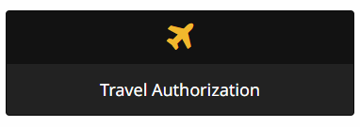

Select: Begin a new Travel Authorization Form | 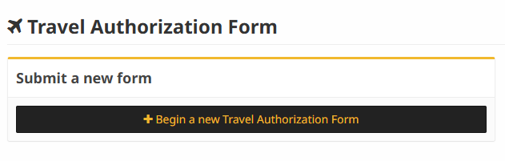

The user’s name who is logged in will auto populate in the Requester box. If completing the form on behalf of someone else, search for the requester’s name

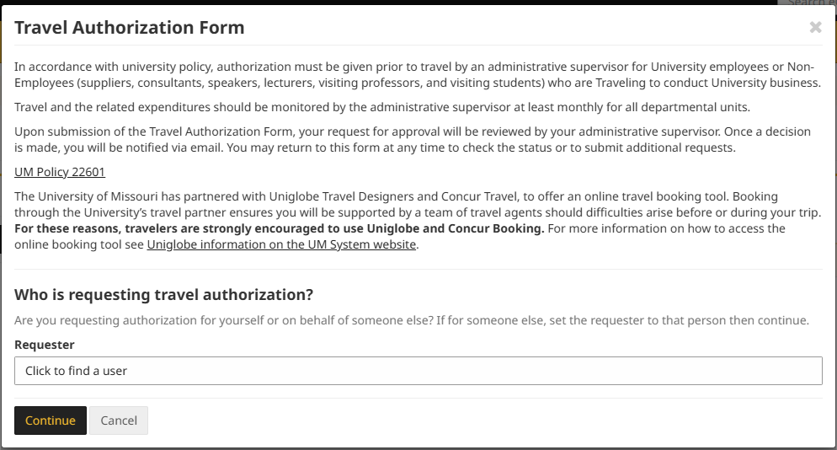

Questions Section

Question #1 – Travel Destination

- If you are not traveling to a foreign country, you will be routed to question #2 after answering no.

- If yes is selected, you will be asked if the trip is for personal purposes. If yes, you only need to continue to complete the travel authorization form if you are traveling to the countries listed in the drop-down box.

- If the trip is not for personal purposes, select the appropriate country from the list provided.

Section #2 – Travel Information

- Complete the series of nine questions. Depending on the answer selected for each question, additional questions may populate and must be answered.

- For question #10, the supervisor field will auto populate with supervisor information from myHR.

- Question #11 asks for the department worker who handles reimbursements related to your travel, but the form can be completed without this information if that person is unknown. Questions #12 is also not required if the approver name is unknown.

Click Save and Continue
- You will be alerted to any required fields left blank if they need completion.

Submit
- If all required fields are complete, the form can be submitted by clicking the accuracy check box and the Submit button

Complete Screen
You will receive a message that the form was submitted successfully, and you can view or print your form here

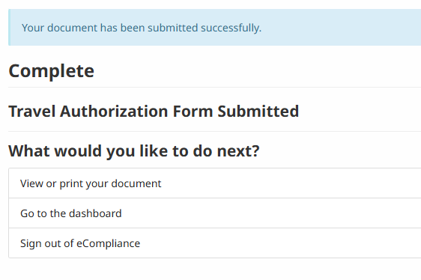

Confirmation Email
An email confirming the Travel Authorization was submitted will be sent to you

