MU Travel Authorization – Supervisor Instructions

You will receive an email when you are listed as a supervisor on a Travel Authorization form. Clicking the circled hyperlink will take you directly to that employee’s form to review.
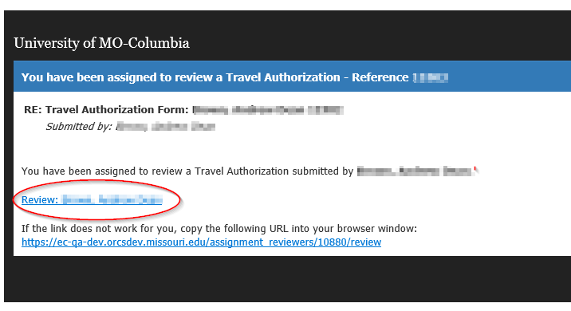

Travel Authorizations assigned to you can also be accessed by logging into eCompliance at:  https://ecompliance.missouri.edu/login  Clicking the alert box on the top bar will open the list of tasks assigned to you | 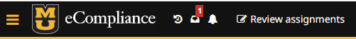

Click on the alert to see the task(s) assigned  Click the Review box to open the form and review the information | 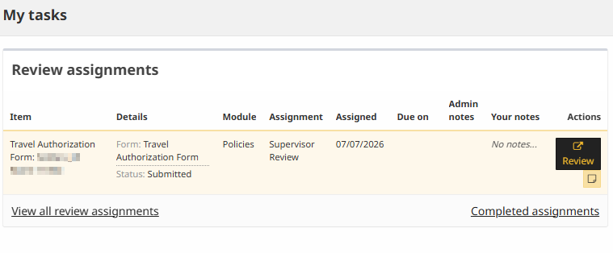

After opening a form for an employee, the left side will show the employee’s information and answers to the form questions  Toggle between the form answers, comments and any attachments at the top | 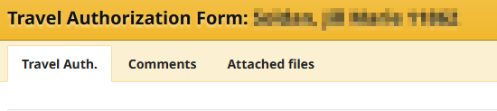

Right side of screen: Approve or deny the request and enter any comments that will be visible for the form submitter or another reviewer to see

Use the options at the top to look at prior reviews or add notes that will only be visible for you to view

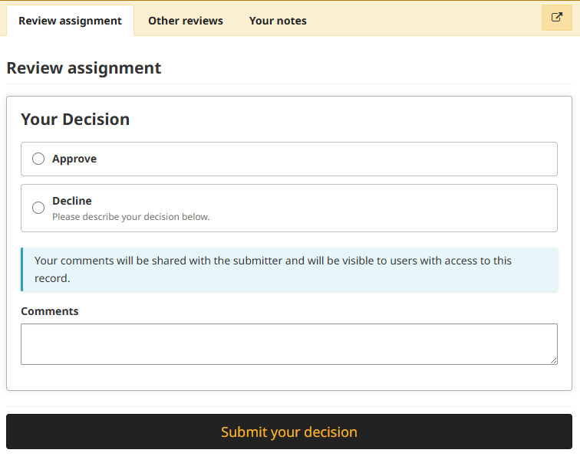

Once you have approved or denied the request, you will receive this message  An email will be sent to the submitter alerting them of the decision | 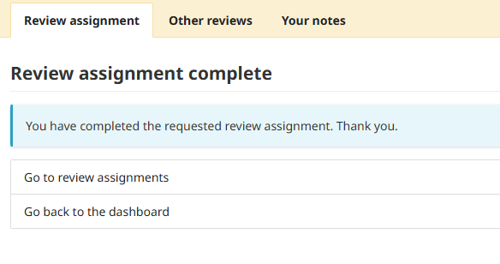

Review Assignments

Currently assigned and completed forms can be viewed by selecting this option from the top bar | 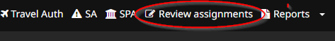

Choose which type of form you want to view and then select search. The results will populate on the right side of the screen.  Keywords can be added to further narrow down results | 