Detailed Plan of Project
  - Overall goals and objectives or specific aims
This proposal serves to support my application for research leave in 2023-2024 at the Leibniz Institute of Freshwater Ecology and Inland Fisheries (IGB) in Stechlin, Germany. During this time, I intend to dedicate myself to scholarly research activities that will result in outcomes that are important for an AAU institution. I have been granted relief from my teaching and service activities for this year (see Letter of Support from School of Natural Resources Director, Dr.
Patrick Market). I have willing German hosts (see Letters of Support from Drs. Grossart and Berger at IGB) and am working collaboratively to plan a novel, large-scale experiment with global collaborators as part of the European Union (EU) AQUACOSM-plus call for Transnational Access (TA, https://www.aquacosm.eu/transnational-access) to the IGB-Stechlin LakeLab in summer 2023. AQUACOSM is an EU network of mesocosm facilities for research on marine and freshwater ecosystems open for global collaboration.
Global change is turning lakes green. There has been a world-wide increase in phytoplankton biomass and in particular, of toxic cyanobacterial harmful algal blooms (CyanoHABs). The estimated costs of HABs within the US average ~ $50 million per year with cumulative totals of one billion over the past several decades¹. Cyanotoxins can be ingested through drinking water, recreational activities, or in contaminated fish; thus, pose serious human health and livestock risks. The overall objective for the research I propose to conduct during research leave at the IGB-Stechlin LakeLab via a collaborative mesocosm experiment is to elucidate the source, persistence, and degradation of the cyanobacteria-produced toxin, microcystin. This information will inform on successional processes and phenology of freshwater phytoplankton, which in turn, will impact their biodiversity and function, including risk factors for consumption of microcystin from a drinking water perspective. My working hypothesis is that seasonal changes in water temperatures and underwater light will affect physical mixing, nutrient availability, promote the presence of cyanobacteria, disrupt their phenology, and change their toxicity.
I plan to attain my overall objective by pursuing the following two specific research aims:
- Identify the direct sources and processes contributing to microcystin in the water column. I hypothesize that physical mechanisms such as mixing with the sediments, water temperature, and light will impact water column microcystin concentrations. I predict that increases in mixing will seed the water column with both resting cells (akinetes) of microcystin-producing cyanobacteria AND microcystin itself.
- Identify the indirect sources and processes that stimulate the growth of microcystin-producing cyanobacteria. I hypothesize that the addition of nutrients (e.g., phosphorus and nitrogen) will stimulate the akinetes to grow and produce toxins. I predict that the persistence of microcystin and its rate of degradation in the water column will be dictated by water temperatures and light. Warmer water temperatures and higher light conditions will activate the microbial community, known degraders of microcystin, and UV-light will accelerate this degradation.

Relevant background and literature
Water quality impacts society, health, economy, and environment; thus, accurate estimates of the timing and impact of potentially toxic CyanoHABs is important for public health protection, a

stable economy, and sound resource management. This critical research will help facilitate climate change adaptation, and in doing so, help protect aquatic ecosystem services. Impairment of surface waters by CyanoHABs have become issues in the political arena, media, and among the general public. The societal and economic consequences of CyanoHABs were exemplified by Lake Erie in August 2014, when over 500,000 people in Toledo, Ohio did not have a safe source of drinking water. The total economic impact of this event was estimated at $65 million in lost benefits and cost the Toledo water treatment plant ~$4 million dollars. CyanoHABs can also substantially increase the cost and time required for water treatment due to interference with treatment processes².
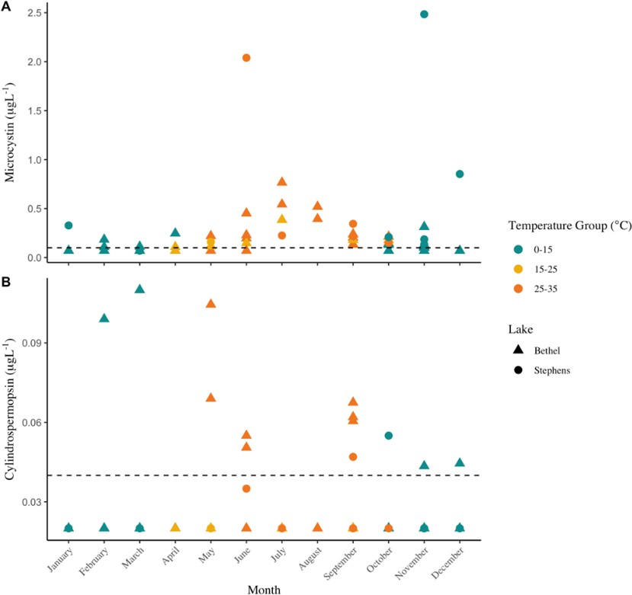
I have preliminary data showing that peaks in year-round cyanotoxin concentrations (microcystin [Fig. 1A] and cylindrospermopsin [Fig. 1B]) occur when the water column mixed with the sediments, and water temperatures and light were low. During these times, there were no toxin-producers present in the water column. My interpretation is that the cyanotoxins persist longer during the non-summer months and may be seeded from lake sediments.
Figure 1. Non-summer cyanotoxins were measured when toxin-producing cyanobacteria were not present. In November, when the maximum microcystin concentration was measured, the phytoplankton community in the water column was 64% cryptophytes and only 4% cyanobacteria. The cyanobacteria were dominated (60%) by Plagioselmis nanoplanktica / Rhodomonas minuta; not a known toxin producer. In March, during maximum cylindrospermopsin concentrations, the water column phytoplankton community was 81% cryptophytes and 0% cyanobacteria.
A recent review article developed a conceptual model of the lake microcystin cycle³ (Fig. 2). They demonstrate that in addition to microcystin falling out of the water column into the sediments, the sediments can also serve as a source of microcystin, via resuspension and diffusion (Fig. 2). The authors make a plea for more work on sediment microcystin fluxes and drivers of biodegradation³. If funded, this proposal will answer that call.

Significance of project
Implications of this work will be assessing the risk of year-round microcystin in surface waters used as sources of drinking water, and implications for the food web and organisms that live within the lake year-round that can accumulate toxins in their tissues. This unique opportunity to conduct this multi-faceted experiment will cement the previously established collaboration between myself and IGB, and result in at least three peer-reviewed publications and potential opportunities for future funding. The results of this project will aid in assessing the likelihood of high cyanotoxins- contaminants difficult and costly to remove during the drinking water

treatment process. Chronic exposure to low doses of cyanotoxins have been found to promote tumor formation and may be responsible for the development of cancer⁴. The risk of colorectal cancer was multiplied 8x when water with more than 0.05 µg L⁻¹ of microcystin was consumed⁴.
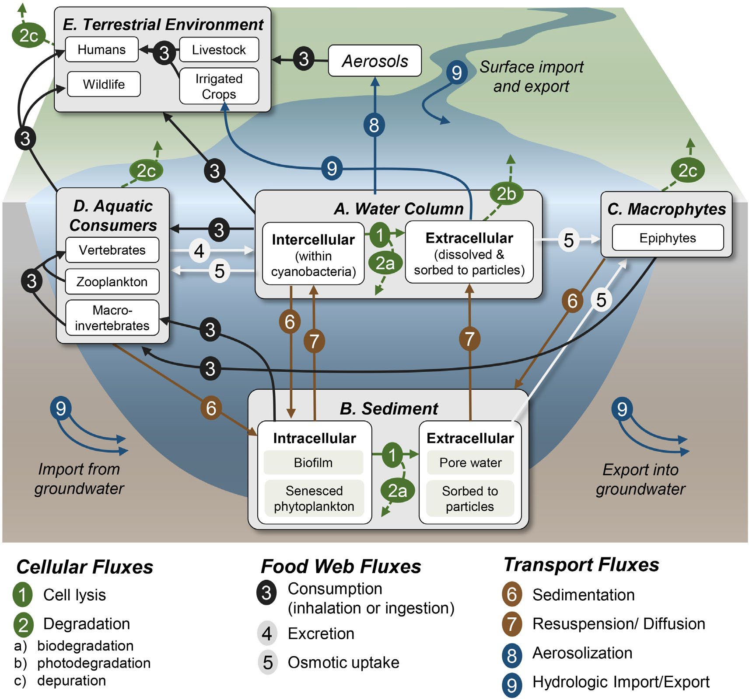
Figure 2. The microcystin cycle
in lakes. The major pools (A–E) of microcystin and subpools (white boxes within major pools) are labeled with light gray boxes. The major fluxes among these pools are denoted with arrows. The fluxes (arrows) are between the major pools and inclusive of all subpools unless arrows specifically connect two subpools³.

Methods and procedures
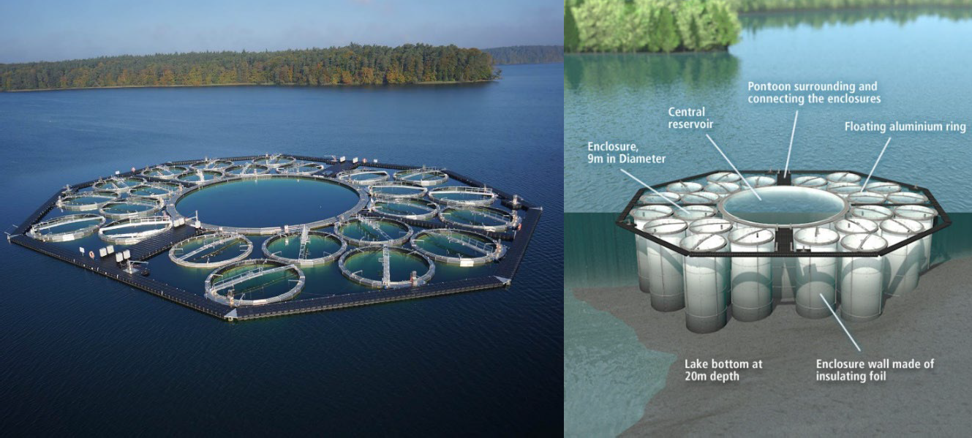

Figure 3. IGB LakeLab in Lake Stechlin, Germany. The LakeLab in the deep clear-water Lake Stechlin, NE Germany, consists of 24 cylindrical enclosures encompassing large water volumes of 1270 m³ (9 m diameter, 20 m depth) each. The special features of the LakeLab are the unique combination of large size and number of mesocosms which enable multi- factorial designs and new research perspectives. Flexible curtains attached to aluminum floats extending into the sediment enable experiments on benthic-pelagic coupling, including the one proposed here.

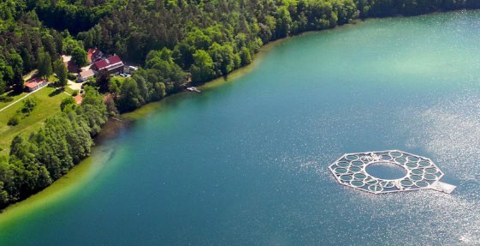
In the summer of 2023, I propose to conduct a LakeLab/mesocosm experiment (Fig. 3) that aligns with my research interests- related to cyanotoxin persistence and degradation- with implications for year-round cyanotoxin concentrations. I will vary temperature and light within the vertical mesocosm water column through stratification. When the water column is stratified, the bottom waters (hypolimnion) will be cooler (~4°C) and dark relative to the surface waters (epilimnion). When we mix the water column via an air lift, temperature will be the same throughout the water column and light will attenuate with depth. These two conditions (e.g., stratified vs isothermal) will allow us to incubate sediment cores spiked with microcystin, under four different temperature and light scenarios, while also creating a gradient for akinete mixing from the lake sediments (Fig. 4). I will then mimic these experimental conditions within Lake Stechlin itself, using the nearshore to offshore gradient within the lake (Fig. 4). This will be achieved by sampling the sediments and water column of the lake on a gradient representing the experimental mesocosm conditions of sediment mixing, water temperature and light on a nearshore to offshore continuum.
Figure 4. Lake Stechlin, Germany. The LakeLab is
pictured from an aerial view, demonstrating the nearshore to offshore gradient.
I will use a three-fold approach to test the hypotheses developed in Research Aims 1 & 2: I will address specific aim (1) through sealed sediment cores that are spiked with microcystin and then incubated in the horizontal layers of the water column under varying conditions of light and water temperature. I have extensive experience with sediment core incubations and measuring parameters in the overlying water column^{5–7}. I will quantify the rate of microcystin degradation under these varying conditions to elucidate the underlying mechanisms. I will address specific aim (2) via manipulation of the factors that influence microcystin degradation; temperature and light.
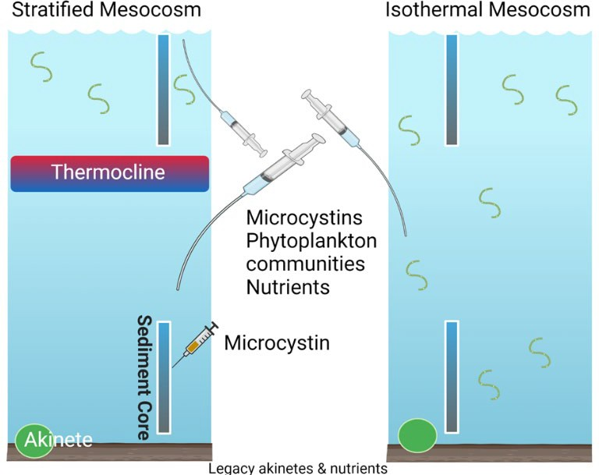
Figure 5. Mesocosm experimental design. Triplicate mesocosms will be stratified and mixed/isothermal (via air lifts). Both the sediment cores and the mescosm water columns will be sampled at regular intervals to estimate microcystin degradation rates. I will also sample for phytoplankton communities and nutrients.

These will be controlled via mixing (Fig. 6)- which the LakeLab has extensive experience manipulating. It is extremely rare for in-lake mesocosms to extend all of the way into the natural lake sediments. This may be one of the only locations in the world we can conduct this experiment, given the history and diversity of cyanobacteria in the sediments and the ability to manipulate their migration. Each mesocosm will have different initial conditions of nutrients and akinete abundance and type. The diverse history of experiments that have been conducted in these mesocosms (https://www.lake-lab.de/index.php/experiments.html) will allow us to have a diversity of cyanobacterial populations in the sediments. We expect to have a gradient in akinete diversity and legacy nutrients contained within the sediments of each mesocosm.
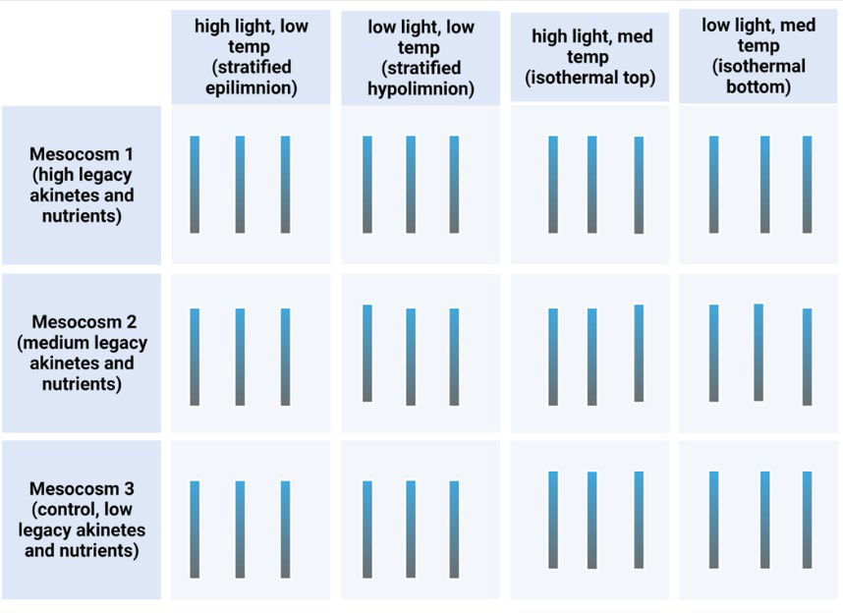

Figure 6. Mesocosm experimental treatments. Triplicate sediment cores will be incubated under three variations in light and temperature, which will be manipulated via physically mixing the water column.

Justification
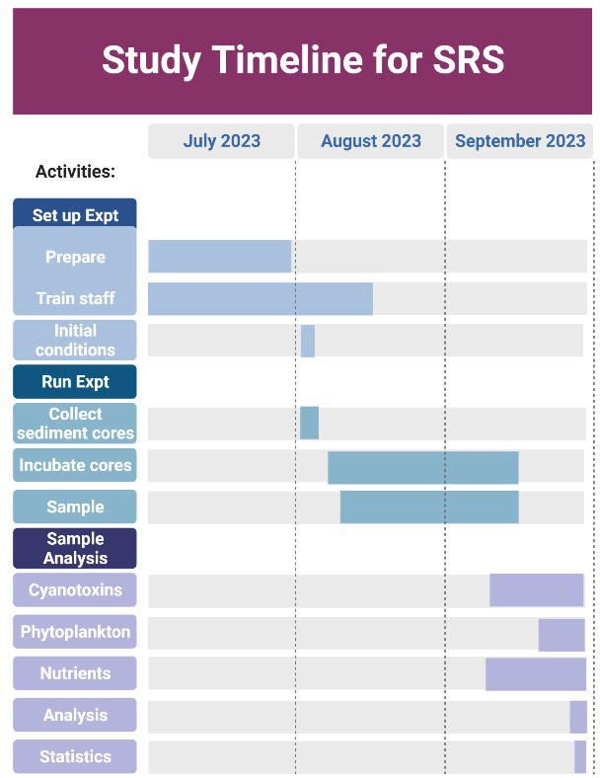
This unique opportunity to conduct this multi-faceted experiment will cement the previously established collaboration between myself and
IGB, and result in at least three peer-reviewed high-quality publications and potential opportunities for future funding and collaborative research. My next steps will be to apply the information gained in these controlled mesocosm experiments to field studies in Missouri reservoirs. I intend to use the mesocosm results as preliminary data and proof of concept for a NSF Mid-Career Advancement (MCA) proposal to support the application of experimental results to “real-world” settings. Also, through the process of working with world-renowned limnologists (Drs. Grossart and Berger), I will acquire specific research skills and expertise in microbial ecology and experimental design that I can teach my MU graduate and undergraduate researchers and apply to my research program here- which will advance the mission of MU.

Study Timeline

  - Requests for Summer Research Salary
Throughout my career, I have been successful in rapidly launching large research programs within collaborative institutes over short periods of time and look forward to continuing this trajectory at IGB. I have experience with mesocosm experiments⁸, and my IGB collaborators continuously run these types of experiments. Data analysis and writing will occur after the period of the SRS. I will be on research leave until August 1, 2024 with no teaching nor service commitments, which should allow for sufficient time to write up the experiments as peer-reviewed publications.

Citations
    - Anderson, D., Hoagland, P., Kaoru, Y. & White, A. W. Estimated annual economic impacts from harmful algal blooms (HABs) in the United States. (2000).
    - Merel, S., Clément, M. & Thomas, O. State of the art on cyanotoxins in water and their behaviour towards chlorine. Toxicon 55, 677–691 (2010).
    - Shingai, Q. K. & Wilkinson, G. M. Microcystin as a biogeochemical cycle: Pools, fluxes, and fates of the cyanotoxin in inland waters. Limnol Oceanogr Letters lol2.10300 (2022). doi:10.1002/lol2.10300
    - Zanchett, G. & Oliveira-Filho, E. C. Cyanobacteria and cyanotoxins: From impacts on aquatic ecosystems and human health to anticarcinogenic effects. Toxins 5, 1896–1917 Preprint at https://doi.org/10.3390/toxins5101896 (2013)
    - Johansson, J., Vandergucht, D. M., Doig, L. E., Liber, K., Lindenschmidt, K.-E., Baulch, H. & Hudson, J. J. Evidence for internal phosphorus loading in a large prairie reservoir (Lake Diefenbaker, Saskatchewan). Journal of Great Lakes Research 41, 91–99
(2015).
    - Doig, L. E., Hudson, J. J., Hewlett, C., Lindenschmidt, K. E. & Liber, K. Phosphorus release from sediments in a river-valley reservoir in the northern Great Plains of North America. Hydrobiologia 787, 323–339 (2017).
    - Orihel, D. M., Baulch, H. M., Casson, N. J., Parsons, C. T., Seckar, D. C. M. & Venkiteswaran, J. J. Internal phosphorus loading in Canadian fresh waters: a critical review and data analysis. Canadian Journal of Fisheries and Aquatic Sciences 25, 1–25 (2017).
    - Gaskill, J. A., Harris, T. D. & Phytoplankton Community Response to Changes in Light: Can Glacial Rock Flour Be Used to Control Cyanobacterial Blooms? Frontiers in Environmental Science 8, (2020).

I. Book-Related Supporting Documents
NA

Biographical Sketch/Curriculum Vitae

  - Education

University of Waterloo, Ontario, Canada. Environmental Science, B.Sc., 2001. University of Waterloo, Ontario, Canada. Limnology, Ph.D., 2008

  - Employment history

Assistant Professor, School of Natural Resources, University of Missouri, Missouri, US. 2016–present.
Research Associate, Global Institute for Water Security, University of Saskatchewan, Saskatchewan, Canada. Winter Limnology. 2014–2016.
Research Associate, Department of Biology, University of Saskatchewan, Saskatchewan, Canada. Reservoir Limnology. 2012–2014.
Postdoctoral Fellow, School of the Environment, Trent University, Ontario, Canada. Watershed Science. 2008–2012.

  - Research Support
R.L. Missouri phytoplankton. Missouri Department of Health and Senior Services
$58,688. 3/1/22 – 8/31/22.
R.L. Flooding impact on cyanobacteria blooms. Missouri Department of Health and Senior Services $103,876. 3/1/21 – 8/31/22.
R.L. and A. Argerich. Statewide Lake Assessment Project. Missouri Department of Natural Resources. $205,495. 4/1/21 – 3/31/22.
R.L. Burping ponds: greenhouse gas emissions from Crow Pond and implications for fish habitat. Prairie Fork Conservation Area $19,890. 4/1/19 – 3/31/21.
R.L. and A. Argerich. Algae, stench, and death: are algal toxins present in Missouri fish? Missouri Water Resources Research Center, United States Geological Survey (USGS).
$42,169. 3/1/18 – 12/30/20.
  - List of publications (selected from 51 publications; full list available at: http://scholar.google.com;)
    - Reinl, K.L., Harris, T.D., Almela*, P., Berger, S.A., Bizic, M., Burnet, S.H., Urrutia Cordero, P., Grossart, H.P., Ibelings, B.W., Jakobsson, E., Knoll, L.B., Lafrancois, B.M., McElarney, Y., Morales-Williams, A.M., Obertegger, U., Ogashawara, I., Paule-Mercado, M.C., Ma, C., Peierls, B.L., Rusak, J.A., Sarkar, S., Sharma, S, Trout-Haney, J.V., Venkiteswaran, J.J., Wain, D.J., Warner, K., Weyhenmeyer, G.A., Yokota, K. Blooms also like it cold. Accepted at Limnology & Oceanography Letters.

    - Cianci-Gaskill*, J.A., Knott, K., O’Hearn, R., Argerich, A., Niswonger, D., Wenzel, J., Whittier, J.B., 2022. Microcystin accumulation in Sportfish from an agricultural

reservoir differs among feeding guild, tissue type, and time of sampling. Aquatic Toxicology. 250.

    - Rushford*, C.A., Miller, G.L. 2022. Detection of cyanotoxins in
irrigation water and potential impact on putting green health. International Turfgrass Society Research Journal. 14:994-996. DOI:10.1002/its2.40.
    - Bhattacharya*, R., Jones, J.R., Graham, J.L., Obrecht, D.V., Thorpe, A.P., Harlan, J.D., 2022. Nonlinear multidecadal trends in organic matter dynamics in Midwest reservoirs are a function of variable hydroclimate. Limnology & Oceanography. DOI: 10.1002/lno.12220

    - Reinl, K.L., Harris, T.D., Elfferich, I., Coker, A., Zhan, Q., De Senerpont Domis, L.N., Morales-Williams, A.M., Bhattacharya*, R., Grossart, H.P., Sweetman, J.N. 2022. The role of organic nutrients in structuring freshwater phytoplankton communities in a rapidly changing world. Water Research.

    - Reinl, K.L., Brookes, J.D., Carey, C.C., Harris, T.D., Ibelings, B.W., Morales-Williams, A.M., De Senerpont Domis, L.N., Atkins, K.S., Isles, P.D.F., Mesman, J.P., Rudstam,

L.G., Stelzer, J.A.A., Venkiteswaran, J.J., Yokota, K., Zhan, Q. 2021. Cyanobacterial blooms in oligotrophic lakes: Shifting the high nutrient paradigm. Freshwater Biology. DOI: 10.1111/fwb.13791.

    - Jane, S.F., Hansen, G.J.A., Kraemer, B.M., Leavitt, P.R., Pilla, R.M., Williamson, C.E., Woolway, R.I., Arvola, L., Chandra, S., DeGasperi, C.L., Diemer, L., Dunalska, J., Erina, O., Flaim, G., Grossart, H.P., Hambright, K.D., Hein, C., Hejzlar, J., Janus, L.L., Jenny, J.P., Jones,
J., Knoll, L.B., Leoni, B., MacKay, E., Matsuzaki, S.I., McBride, C., Muller-Navarra, D.C., Paterson, A.M., Pierson, D., Rogora, M., Rusak, J., Sadro, S., Saulnier-Talbot, E., Schmid, M., Sommaruga, R., Thiery, W., Verburg, P., Weyhenmeyer, G., Yokota, K., Rose, K.C. 2021.
Widespread deoxygenation of temperate lakes. Nature. DOI:10.1038/s41586-021-03550-y.

    - Gaskill*, J.A., Harris, T.D., and 2020. Phytoplankton community response to changes in light: Can glacial rock flour be used to control cyanobacterial blooms? Frontiers in Environmental Science. 8:540607. DOI: 10.3389/fenvs.2020.540607.

    - Orihel, D.M., Baulch, H., Casson, N., Parsons, C., Seckar, D., Venkiteswaran, J. 2017. Internal phosphorus loading in Canadian fresh waters: a critical review and data analysis. Canadian Journal of Fisheries and Aquatic Sciences. 74 (12): 2005–2029.
https://doi.org/10.1139/cjfas-2016-0500. Editors Choice award. Authorship order was alphabetical, exclusive of the first author.

    - Johansson, J., Vandergucht, D., Doig, L., Liber, K., Lindenschmidt, K.-E., Baulch, H., Hudson, J. 2015. Evidence for internal phosphorus loading in a large prairie reservoir (Lake Diefenbaker, Saskatchewan). Journal of Great Lakes Research. 41(Suppl. 2): 91–99. doi: 10.1016/ j.jglr.2015.07.003.

Current and Pending Internal and External Support

  - Research Council Support from the past 5 years

What happens in reservoirs when nobody’s looking? Year-round assessment of cyanobacterial harmful algal blooms in a Missouri drinking water reservoir. MU Research Council $7,423.
11/1/19 – 10/31/20.

Other Internal Support Current internal funds:
Source of support: Prairie Fork Conservation Area
Project title: Nutrient controls on cyanotoxin production by harmful algae in Crow Pond Dates of entire project period: 4/1/21 – 3/31/23
Award amount: $20,267
Extend of overlap with proposed project: None

Pending internal funds:

Source of support: Prairie Fork Conservation Area
Project title: Is Vitamin B1 causing more toxic and green lakes? Dates of entire project period: 4/1/23 – 3/31/25
Award amount: $20,000
Extend of overlap with proposed project: None

External Support Current external funds:
Source of support: USDA-NIFA-SPECA
Project title: Reservoir Observer Student Scientists: Participatory science education model Dates of entire project period: 9/1/22 – 8/31/25
Award amount: $150,000
Extend of overlap with proposed project: None

Source of support: EPA-STAR
Project title: Valuing water quality improvements in heartland reservoirs Dates of entire project period: 8/1/22 – 7/31/25
Award amount: $740,014
Extend of overlap with proposed project: None

Source of support: Missouri Water Resources Research Center, United States Geological Survey (USGS)
Project title: Year-round cyanotoxin threats to Missouri surface waters

Dates of entire project period: 9/1/22 – 8/31/23 Award amount: $24,953
Extend of overlap with proposed project: None

Source of support: Environmental Protection Agency (EPA) via Missouri Department of Natural Resources
Project title: Statewide Lakes Assessment Project Dates of entire project period: 4/1/22 – 3/31/23 Award amount: $202,886
Extend of overlap with proposed project: None

Source of support: Environmental Protection Agency (EPA) via Missouri Department of Natural Resources
Project title: 2022 National Lakes Assessment (NLA3) Survey Dates of entire project period: 4/1/22 – 3/31/23
Award amount: $100,390
Extend of overlap with proposed project: None

Source of support: National Aeronautics and Space Administration (NASA), A.21 Remote Sensing of Water Quality
Project title: Retrospective analysis of anthropogenic change in Midwest reservoirs: Integrating earth observing data with statewide reservoir monitoring programs
Dates of entire project period: 4/1/22 – 3/31/25 Award amount: $478,731
Extend of overlap with proposed project: None

Source of support: ARS-USDA-MU
Project title: Changing agricultural practices impact on nutrient loading to the LMRB and potential for harmful algal blooms
Dates of entire project period: 01/01/22– 12/31/22 Award amount: $28,068
Extend of overlap with proposed project: None
Source of support: US Department of Agriculture - National Institute of Food and Agriculture - Research and Extension Experience for Undergraduates
Project title: Filling the Pipeline - Preparing the Next Generation of Watershed Management Extension Professionals
Dates of entire project period: 1/1/21– 12/31/25 Award amount: $499,967
Extend of overlap with proposed project: None

Source of support: United States Geological Survey (USGS)
Project title: Bizarro cyanotoxins: when do green reservoirs become toxic? Dates of entire project period: 9/1/21 – 2/1/23
Award amount: $21,736
Extend of overlap with proposed project: None

Pending external funds:

Source of support: National Science Foundation (NSF), Macrosystems
Project title: Collaborative Research: MRA: On thin ice- implications of shorter winters for the future of freshwater phytoplankton phenology and function
Dates of entire project period: 5/1/23 – 4/30/28 Award amount: $992,750
Extend of overlap with proposed project: None

Source of support: Environmental Protection Agency (EPA) via Missouri Department of Natural Resources
Project title: Statewide Lakes Assessment Project Dates of entire project period: 4/1/23 – 3/31/24 Award amount: $258,714
Extend of overlap with proposed project: None

Source of support: Graduate Women in Science
Project title: Is Vitamin B1 causing more toxic and green lakes? Dates of entire project period: 7/1/23 – 6/30/24
Award amount: $10,000
Extend of overlap with proposed project: None

- Budget Request and Justification

Budget Table (Summer Research Salary & companion funds)

Budget Category | Item | Rate | Effort | Totals
Summer Research Salary | (1) Smith, J SRS (1 month)  (2) + fringe benefits (35.07%) | $4,917  $2,426 | 1 month | $9,343
Research Travel | - Return flight from Columbia,  Missouri to Berlin, Germany  - Lodging at the Stechlin LakeLab  - Meals at the IGB Guesthouse | $2,302  $22/day  $15/day | 90 days | $5,632
 | Total proposed expenditures |  |  | $12,975

Budget Justification

SRS (Items 1 & 2): This global, collaborative experiment as part of the EU AQUACOSM-plus project involves many partners and lots of logistics and has been planned to occur at the IGB-Stechlin LakeLab in July- September 2023. It cannot be completed during the regular academic year, as it must be conducted during summer months when the lake water temperatures are warm, and collaborators are available and not busy taking classes (graduate students) or teaching (PIs).

Research Travel (Items 3-5): Funds are requested to defray costs for foreign travel to Berlin, Germany (the closest airport to Stechlin, Germany). The cost of the lowest round-trip airfare is provided. I also request funds for lodging and meal expense reimbursement during the experiment. Accommodation at IGB’s guest house is $22/night and the experiment, including planning, set up and take down, is budgeted for 90 days (July 1, 2023 to September 30, 2023). A modest food allowance of $15/day will allow me to reimburse for meals at the IGB guesthouse.

