
New Customizable iPSC Services!

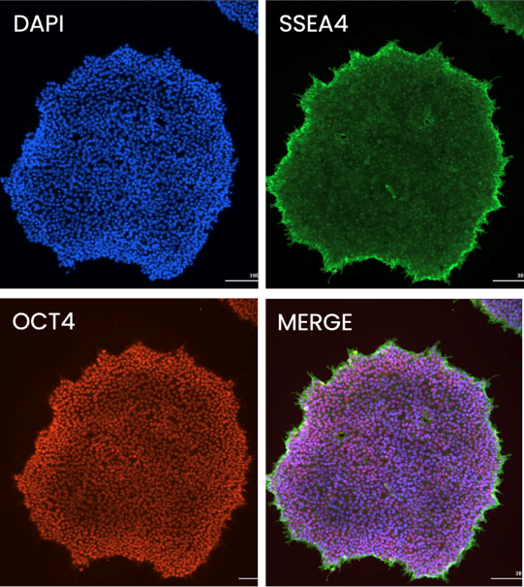
Induced pluripotent stem cells (iPSCs) are versatile, expandable research tools for studying human development, disease mechanisms, and therapeutic discovery. Through a collaborative partnership between the University of Missouri Animal Modeling Core (AMC) and the UCLA Human Stem Cell & Genome Engineering Center (HSCGEC), the AMC now offers centralized access to validated iPSC reprogramming, advanced stem cell characterization, precision genome engineering, comprehensive quality control, and scalable cell line banking services. This integrated service platform supports a streamlined path from experimental design to engineered cell line generation, accelerating discovery across disease modeling, functional genomics, drug discovery, and translational research.

- Expert consultation and experimental design support.
- Integration-free iPSC reprogramming and genome engineering.
- Automation-enabled colony selection and genomic QC.
- Comprehensive support for academic, clinical, and industry partners.
- Designed for scalable and high-quality research support.

Integration-free iPSC reprogramming
- Human fibroblasts
- Peripheral blood mononuclear cells (PBMCs)
- >95% success reported by HSCGEC
- Integration-free methodologies

Precision CRISPR engineering
- Knockout and knock-in cell models
- Safe habor locus engineering
- Inducible CRISPRa and CRISPRi systems
Pluripotent stem cell characterization and QC
- OCT4 and SSEA4 immunocytochemistry
- Mycoplasma screening
- Whole-genome stability assessment
- CNV analysis for engineered lines

Cell line banking
- Scalable storage solutions
- Fast and reliable retrieval
- Supports long-term project continuity



If you are considering a project or would like to discuss experimental design, the AMC team would be happy to provide a short consultation to help identify the best workflow for your research. We can assist with project planning, service selection, feasibility discussions, and coordination with HSCGEC to ensure your iPSC reprogramming, genome engineering, characterization, or cell banking needs are matched with the appropriate resources. Contact the AMC to learn how these new customizable iPSC services can support your next study.
In partnership with:
Contact Us: Daniel Davis, PhD - Core Director | (573) 884-1804 | davisdaniel@missouri.edu

